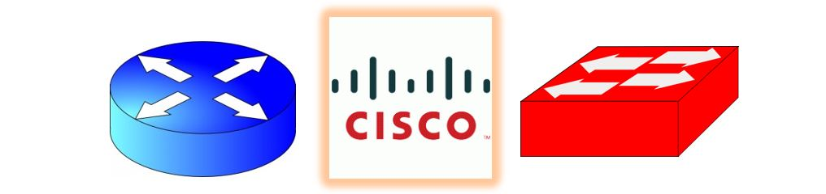
Cisco NetAcademy CCNA Introduction to Networking Q&A
Learning modules 8.1.1. – 8.6.2 and supporting resource documents
BESIDES ANSWERING THESE QUESTIONS YOU SHOULD ALSO BE DEVELOPING YOUR CLI REFERENCE if anything new popped up.
Questions | Answer
- What does the network layer allow to happen?
- What protocols are included in this layer?
- Outline the basic operations that occur in end-to-end communication.
- The network layer specifies the _____ structure. Does it care what data is cared in the packet?

IP encapsulates the ___ layer ____.
- What devices examine the IP Header.
- Does the IP address or the data change as it goes through intermediary devices?
- List characteristics of IP as well as what they mean or do for the communication process.
- If your media is unreliable, what does IP do to recover? Or does another layer have to do this?
- What does IP consider when preparing for a type of media communication?
- List the fields and purpose within the IPv4 header.
- Why will a router sometimes fragment a packet?
- List issues with IPv4
- What improvements does IPv6 provide?
- Outline the fields in an IPv6 header and their uses.
- What is a EH header and what can its use be?
- Does the host device create its own routing table?
- What is the IP (both IPv4 and IPv6)address of a local loopback?
- What is a local host? A remote host? How is that determined?
- Can a local host reach other local hosts without the use of other devices to relay other than the switch which connects them?
- What is routing?
- What are features of a default gateway?
- How does a host know its own default gateway?
- How does the pc get a default gateway route in its own routing table?
- What is the purpose of a default route?
- How can you look at your own PCs routing table? What did you find? Add a snapshot to the bottom of this document.
- What are the 3 sections of a host routing table?
- Once your default router gets the packet, what does it do with it?
- What is the “longest” matching route entry referred to?
- Explain the types of entries in a router’s route table.
- What are the two ways a routing table is built?
- What is the configuration of a static route? What is a drawback of a static route?
- Outline static routing characteristics.
- What is the key difference and benefit of dynamic routes?
- What does dynamic routing automatically do?
- Is it common to see both types in a routing table?
- How do you display a routers routing table?
- What do the route source codes represent and how are those routes created?
- What is unique about a default route?

Read the article: [Networking] Router vs Switch vs Hub

What are the cons of using hubs instead of switches?

Where can a hub be useful?

Read the article: Europe just ran out of new IPv4 addresses

How many IPv4 addresses could be returned to the pool each year and how? Is it enough?

Explore the site: Cisco - IP Routing

Under Technology Q&A: What types of routing protocols are outlines?

