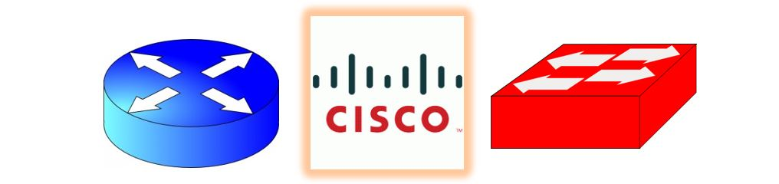
Cisco NetAcademy CCNA Introduction to Networking Q&A
Learning modules 6.1.1 - 7.5.2 and supporting resource documents
BESIDES ANSWERING THESE QUESTIONS YOU SHOULD ALSO BE DEVELOPING YOUR CLI REFERENCE if anything new popped up.
Questions | Answer
- What is the function of the data link layer?
- Why is the data link layer helpful as technology evolves?
- Explain the function of the two datalink sublayers
- What are common MAC sublayer standards in use today?

Explain more the role of the MAC sublayer in data encapsulation.
- What role does the router interface play in moving the message along it path and changes in the media form one subnet to the next?
- Does the IETF define the standards for the network access layer?
- Explain the difference between a physical and logical topology.
- What types of WAN topologies will you encounter? Outline their characteristics.
- What types of LAN topologies will you may encounter, including legacy? Outline their characteristics.
- Explain half- and full-duplex communication. What if both sides are not configured for the same communication type?
- Outline the types of network access rules employed to reduce collisions and bottlenecks.
- Ethernet doesn’t need an access method. T or F
- Wireless uses a _____ access method. If more than one device transmits at the same time, what is the outcome?
- Explain CSMA/CA. Do either CSMA/CD or CSMA/CA scale well?
- Detail the data link frame, its fields and their purpose and discuss how it changes as it moves through the network.
- Outline specifications of a layer 2 address and how it is used in processing messages.
- What process does the router do on receipt of the message?
- List common WAN protocols in place in past years. What protocols are replacing them now?
- What dictates the layer 2 protocol used?
- What standards define Ethernet operation? What bandwidths area supported?
- Outline the Ethernet MAC sublayer and standards involved.
- Legacy Ethernet used what topologies and were __ duplex?
- Outline the Ethernet frame, fields and their uses.
- Layer 3 addressing uses the base ___ number system and layer 2 addressing uses the base __ number system. IPv4? And IPV6? Are normally represented in what base number systems?
- What is an alternate way of indicating a number is in hex?
- How are MAC addresses kept unique? What else is it called and where is it stored?
- If for some reason they aren’t unique, what can you do?
- So for and end device to accept a message, what must match its own? What other message types will it accepts?
- Outline unicast, multicast and broadcast addressing/communication. Also indicate how each might be used and by which protocols or message types.
- Discuss how a switch uses the Ethernet MAC addresses.
- What is the MAC address table? Is it full on power on of the switch? What is another name for this table?
- If a MAC table does not have a device present that is in the message, what is the next process? How does it filter once it knows a port/MAC combination?
- How can a switch port have multiple MACs associated with it?
- If an IP address of a destination is not on the same subnet, what MAC address is in the message to forward the message along?
- Discuss the types of frame forwarding methods used by switches.
- Explain buffering and how it is used.
- What roles does bandwidth and duplex settings play between switch and device? What is auto-negotiation?
- What does auto-MDIX do?

Read the article: 4 things you need to know about Industrial Ethernet and What Are the Differences in Industrial Ethernet Types?

What are the protocols called in industrial communication?

What are key differences in industrial Ethernet LANs?

