Number of clusters Clustering

http://www.holehouse.org/mlclass/13_Clustering.html
Previous Next Index
Unsupervised learning - introduction
- Talk about clustering
  - Learning from unlabeled data
- Unsupervised learning

  - Useful to contras with supervised learning
- Compare and contrast
  - Supervised learning
    - Given a set of labels, fit a hypothesis to it
  - Unsupervised learning
    - Try and determining structure in the data
    - Clustering algorithm groups data together based on data features
- What is clustering good for

  - Market segmentation - group customers into different market segments
  - Social network analysis - Facebook "smartlists"
  - Organizing computer clusters and data centers for network layout and location
  - Astronomical data analysis - Understanding galaxy formation
K-means algorithm
- Want an algorithm to automatically group the data into coherent clusters
- K-means is by far the most widely used clustering algorithm
Overview
- Take unlabeled data and group into two clusters
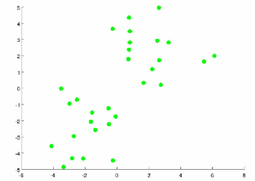
- Algorithm overview
  - 1) Randomly allocate two points as the cluster centroids
    - Have as many cluster centroids as clusters you want to do (K cluster centroids, in fact)
    - In our example we just have two clusters
  - 2) Cluster assignment step
    - Go through each example and depending on if it's closer to the red or blue centroid assign each point to one of the two clusters
    - To demonstrate this, we've gone through the data and "colour" each point red or blue
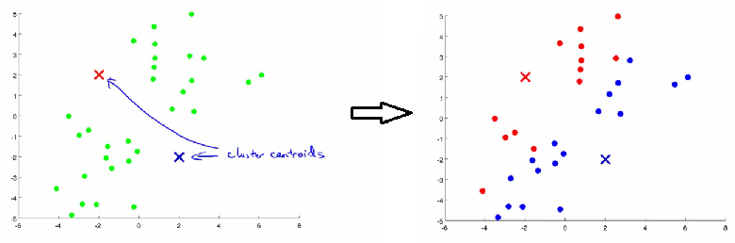
  - 3) Move centroid step
    - Take each centroid and move to the average of the correspondingly assigned data-points
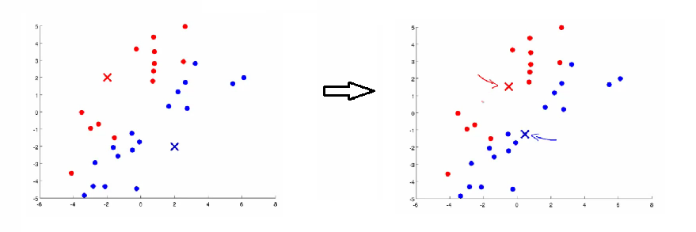
    - Repeat 2) and 3) until convergence
- More formal definition
  - Input:
    - K (number of clusters in the data)
    - Training set {x¹, x², x³ ..., x^{n})
  - Algorithm:
    - Randomly initialize K cluster centroids as {μ₁, μ₂, μ₃ ... μ_{K}}
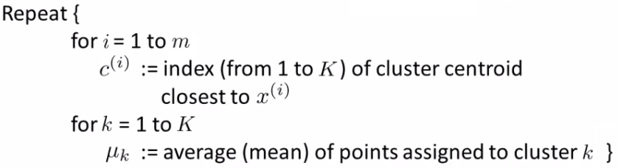

        - Loop 1
          - This inner loop repeatedly sets the c^{(i)} variable to be the index of the closes variable of cluster centroid closes to x^{i}
          - i.e. take i^{th} example, measure squared distance to each cluster centroid, assign c^{(i)}to the cluster closest
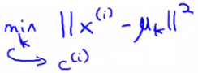
        - Loop 2

          - Loops over each centroid calculate the average mean based on all the points associated with each centroid from c^{(i)}
    - What if there's a centroid with no data

      - Remove that centroid, so end up with K-1 classes
      - Or, randomly reinitialize it

        - Not sure when though...
K-means for non-separated clusters
- So far looking at K-means where we have well defined clusters
- But often K-means is applied to datasets where there aren't well defined clusters
  - e.g. T-shirt sizing
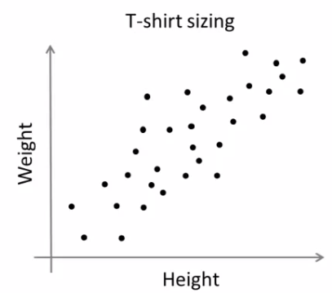
- Not obvious discrete groups
- Say you want to have three sizes (S,M,L) how big do you make these?
  - One way would be to run K-means on this data
  - May do the following
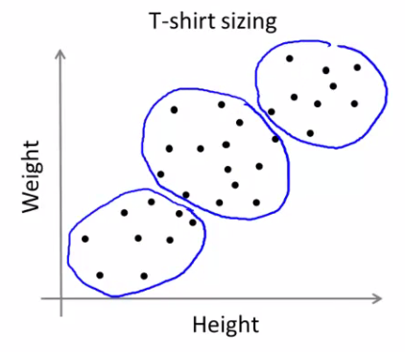
  - So creates three clusters, even though they aren't really there
  - Look at first population of people
    - Try and design a small T-shirt which fits the 1st population
    - And so on for the other two
  - This is an example of market segmentation

    - Build products which suit the needs of your subpopulations

K means optimization objective
- Supervised learning algorithms have an optimization objective (cost function)
  - K-means does too
- K-means has an optimization objective like the supervised learning functions we've seen
  - Why is this good?

  - Knowing this is useful because it helps for debugging
  - Helps find better clusters
- While K-means is running we keep track of two sets of variables
  - c^{i} is the index of clusters {1,2, ..., K} to which x^{i} is currently assigned
    - i.e. there are m c^{i} values, as each example has a c^{i} value, and that value is one the the clusters (i.e. can only be one of K different values)
  - μ_{k}, is the cluster associated with centroid k
    - Locations of cluster centroid k
    - So there are K
    - So these the centroids which exist in the training data space
  - μ_{c}^{i}, is the cluster centroid of the cluster to which example x^{i} has been assigned to
    - This is more for convenience than anything else
      - You could look up that example i is indexed to cluster j (using the c vector), where j is between 1 and K
      - Then look up the value associated with cluster j in the μ vector (i.e. what are the features associated with μ_{j})
      - But instead, for easy description, we have this variable which gets exactly the same value
    - Lets say x^{i} as been assigned to cluster 5
      - Means that
        - c^{i} = 5
        - μ_{c}^{i}, = μ₅
- Using this notation we can write the optimization objective;
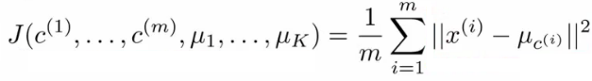
  - i.e. squared distances between training example x^{i} and the cluster centroid to which x^{i} has been assigned to
    - This is just what we've been doing, as the visual description below shows;
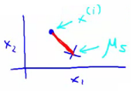
    - The red line here shows the distances between the example x^{i} and the cluster to which that example has been assigned
      - Means that when the example is very close to the cluster, this value is small
      - When the cluster is very far away from the example, the value is large
  - This is sometimes called the distortion (or distortion cost function)
  - So we are finding the values which minimizes this function;
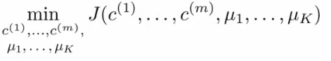
- If we consider the k-means algorithm
  - The cluster assigned step is minimizing J(...) with respect to c¹, c² ... c^{i}
    - i.e. find the centroid closest to each example
    - Doesn't change the centroids themselves
  - The move centroid step
    - We can show this step is choosing the values of μ which minimizes J(...) with respect to μ
  - So, we're partitioning the algorithm into two parts
    - First part minimizes the c variables
    - Second part minimizes the J variables
- We can use this knowledge to help debug our K-means algorithm
Random initialization
- How we initialize K-means
  - And how avoid local optimum
- Consider clustering algorithm
  - Never spoke about how we initialize the centroids
    - A few ways - one method is most recommended
- Have number of centroids set to less than number of examples (K < m) (if K > m we have a problem)0
  - Randomly pick K training examples
  - Set μ₁ up to μ_{K} to these example's values
- K means can converge to different solutions depending on the initialization setup
  - Risk of local optimum
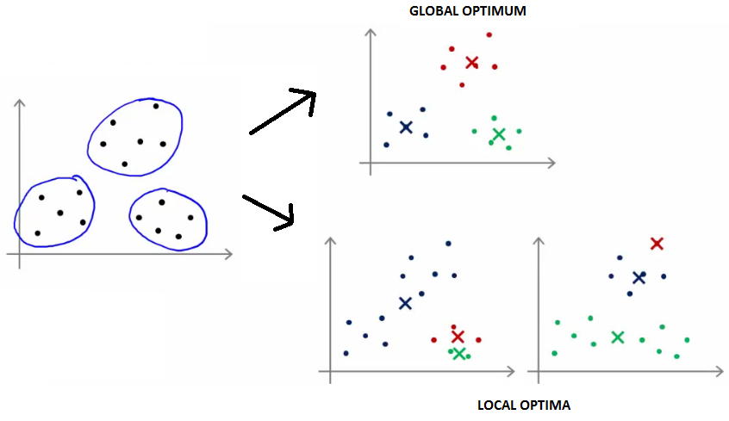
  - The local optimum are valid convergence, but local optimum not global ones
- If this is a concern
  - We can do multiple random initializations
    - See if we get the same result - many same results are likely to indicate a global optimum
- Algorithmically we can do this as follows;
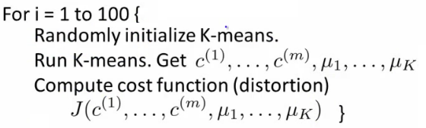
  - A typical number of times to initialize K-means is 50-1000
  - Randomly initialize K-means
    - For each 100 random initialization run K-means
    - Then compute the distortion on the set of cluster assignments and centroids at convergent
    - End with 100 ways of cluster the data
    - Pick the clustering which gave the lowest distortion
- If you're running K means with 2-10 clusters can help find better global optimum

  - If K is larger than 10, then multiple random initializations are less likely to be necessary
  - First solution is probably good enough (better granularity of clustering)
How do we choose the number of clusters?
- Choosing K?
  - Not a great way to do this automatically
  - Normally use visualizations to do it manually
- What are the intuitions regarding the data?
- Why is this hard
  - Sometimes very ambiguous
    - e.g. two clusters or four clusters
    - Not necessarily a correct answer
  - This is why doing it automatic this is hard
Elbow method
- Vary K and compute cost function at a range of K values
- As K increases J(...) minimum value should decrease (i.e. you decrease the granularity so centroids can better optimize)
  - Plot this (K vs J())
- Look for the "elbow" on the graph
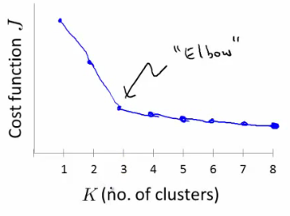
- Chose the "elbow" number of clusters
- If you get a nice plot this is a reasonable way of choosing K
- Risks
  - Normally you don't get a a nice line -> no clear elbow on curve
  - Not really that helpful
Another method for choosing K
- Using K-means for market segmentation
- Running K-means for a later/downstream purpose
  - See how well different number of clusters serve you later needs
- e.g.
  - T-shirt size example
    - If you have three sizes (S,M,L)
    - Or five sizes (XS, S, M, L, XL)
    - Run K means where K = 3 and K = 5
  - How does this look
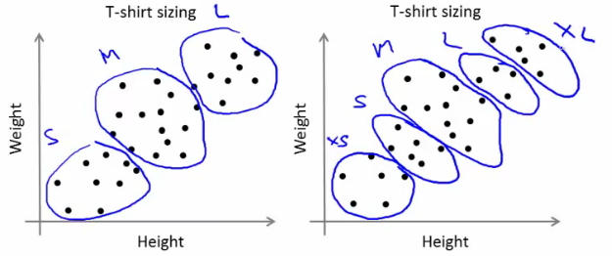
  - This gives a way to chose the number of clusters
    - Could consider the cost of making extra sizes vs. how well distributed the products are
    - How important are those sizes though? (e.g. more sizes might make the customers happier)
    - So applied problem may help guide the number of clusters

