Rezolvare de Probeleme

Fie este definita tipologia unei retele de calculatoare

Sa se:
- Calculeze MASCA pentru fiecare subretea;
- Sa se repartizeze spatiul de adrese IP pentru fiecare subretea mentionindu-se destinatia acesteia;
- Sa se elaboreze Tabela de rutare pentru fiecare Router in parte;
- Sa se demonstreze functionalitatea configuratiilor egectuate.

Formula de calcul:
N=]log2(max{m1, m2, m3, ..mn}+2)[,
Unde: m1,m2 … - numarul de Host-uri in fiecare subretea;
Max – valoarea maximala din sirul de numere;
Log2 – logarifm in baza 2;
]…[ - rotungire pina la numarul intreg mai mare.
In baza topologiei se formuleaza egalitatea:
N=]log2(max{11, 9, 8, 14}+2)[ = ]log2(16)[ = 4.
N=4 – indica numarul de zerouri in masca subretelei si 2**4 – indica numarul maximal de adrese in subretea.

Masca tuturor subretelelor este:
11111111.11111111.11111111.11110000 – in cod binar
255.255.255.240 in cod zecimal.
Modul de calcul:
255.255.255.255-
000.000.000.15
----------------------------
255.255.255.240.
Pentru calcul se ea Adresa care este definita in intervalul de 16 adrese. 0.1.2.3.4.5.6.7.8.9.10.11.12.13.14.15 = 16 adrese.
Masca = 255.255.255.240 = 198.202.110.0/28 ->
32 - 4 = 28 – masca.

SN | IP SN | SN Masc | Destinatie
LAN1 | 198.202.110.0  198.202.110.1  …..  198.202.110.15 | 255.255.255.240 | SN IP Address  Broadcast IP Address
LAN2 | 198.202.110.16  198.202.110.17  …..  198.202.110.31 | 255.255.255.240 | SN IP Address  Broadcast IP Address
LAN3 | 198.202.110.32  198.202.110.33  …..  198.202.110.47 | 255.255.255.240 | SN IP Address  Broadcast IP Address
LAN4 | 198.202.110.48  198.202.110.49  …..  198.202.110.63 | 255.255.255.240 | SN IP Address  Broadcast IP Address

Marcarea porturilor pentru Routere

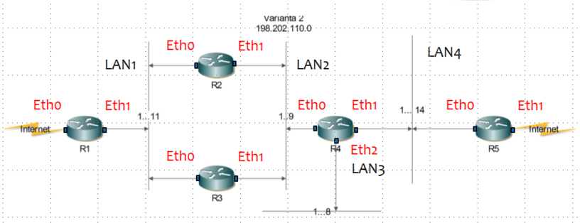

Router | IP SN | SN Masca | Ethernet port
R1 | 198.202.110.0  198.202.110.16  198.202.110.32  198.202.110.48  *.*.*.* | 255.255.255.240  255.255.255.240  255.255.255.240  255.255.255.240  0.0.0.0 | Eth1  Eth1  Eth1  Eth1  Eth0
R2 | 198.202.110.0  198.202.110.16  198.202.110.32  198.202.110.48  *.*.*.* | 255.255.255.240  255.255.255.240  255.255.255.240  255.255.255.240  0.0.0.0 | Eth0  Eth1  Eth1  Eth1  Eth0
R3 | 198.202.110.0  198.202.110.16  198.202.110.32  198.202.110.48  *.*.*.* | 255.255.255.240  255.255.255.240  255.255.255.240  255.255.255.240  0.0.0.0 | Eth0  Eth1  Eth1  Eth1  Eth0
R4 | 198.202.110.0  198.202.110.16  198.202.110.32  198.202.110.48  *.*.*.* | 255.255.255.240  255.255.255.240  255.255.255.240  255.255.255.240  0.0.0.0 | Eth0  Eth0  Eth2  Eth1  Eth1
R5 | 198.202.110.0  198.202.110.16  198.202.110.32  198.202.110.48  *.*.*.* | 255.255.255.240  255.255.255.240  255.255.255.240  255.255.255.240  0.0.0.0 | Eth0  Eth0  Eth0  Eth0  Eth1

Marcarea adreselor IP pentru fiecare port si SN

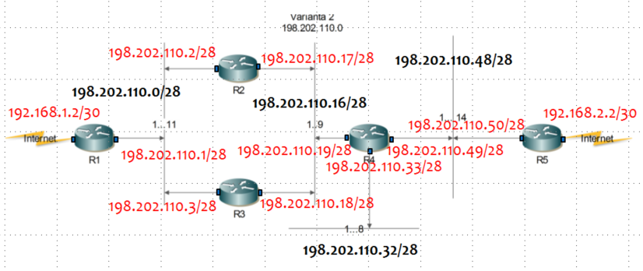

Exemplu de parcugere a traseului din IP:198.202.110.7 -> IP:198.202.110.37

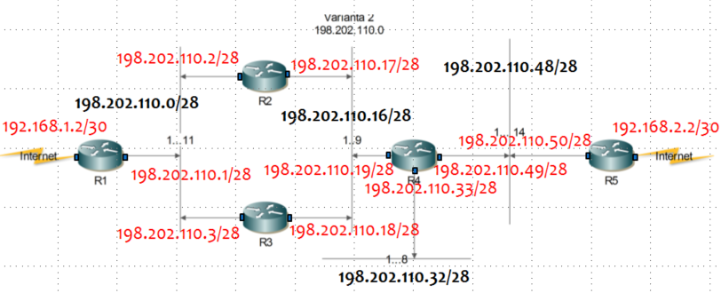

Calculam adresa IP a SN pentru IP:198.202.110.7 si IP:198.202.110.37:
198.202.110.7 AND 198.202.110.37 AND
255.255.255.240 255.255.255.240
198.202.110.0 198.202.110.32

Traseul de transfer a pachetelor:
198.202.110.7/28 -> 198.202.110.2/28 -> 198.202.110.17/28 -> 198.202.110.16/28
-> 198.202.110.19/28 -> 198.202.110.33/28 -> 198.202.110.37/28

